**A PROJECT REPORT**

**ON**

**HARMONIZING THE FUTURE: PROGNOSTICATING SPOTIFY MUSIC SKIPS ACTION PREDICTION WITH MACHINE LEARNING**

Submitted to

**Amity University, Noida**

In partial fulfilment of requirements for the award of the degree

Bachelor of Technology

On

Computer Science and Engineering

By

**MOHAK BHATIA**

**A2305221034**

Under the guidance of

**Dr. M ParthaSarathi**

**CSE Department, ASET**

**DEPARTMENT OF COMPUTER SCIENCE AND ENGINEERING AMITY SCHOOL OF ENGINEERING AND TECHNOLOGY AMITY UNIVERSITY, UTTAR PRADESH**

## **DECLARATION**

## I, **MOHAK BHATIA,** student of B.Tech CSE, hereby declare that the project titled **“HARMONIZING THE FUTURE: PROGNOSTICATING SPOTIFY MUSIC SKIPS ACTION PREDICTION WITH MACHINE LEARNING ”,** which is submitted to Department of Computer Science and Engineering, Amity School of Engineering and Technology (ASET), in partial fulfilment of requirements for the award of the degree Bachelor of Technology in Computer Science and Engineering, has not previously formed the basis for the award of any degree, diploma or any other similar title or recognition. The author attests that permission has been obtained for the use of any copyrighted material, brief excerpts of which have been used in her dissertation/project report. The use of all such material in the scholarly writing has been duly acknowledged under Bibliography and References. I hereby declare that I have gone through project guidelines including policy on health and safety, policy in plagiarism etc.

Noida

Date:

i

**MOHAK BHATIA**

**A2305221034**

## **CERTIFICATE**

On the basis of the declaration submitted by **MOHAK BHATIA** student of B.Tech CSE, I hereby certify that the project titled **“HARMONIZING THE FUTURE: PROGNOSTICATING SPOTIFY MUSIC SKIPS ACTION PREDICTION WITH MACHINE LEARNING”** which is submitted to Amity School of Engineering and Technology, Domain of Engineering and Technology, Amity University Uttar Pradesh, in partial fulfilment of the requirement for the award of the degree of Bachelor of Technology (Computer Science and Engineering), is an original contribution with existing knowledge and faithful record of work carried out by him under my guidance and supervision.

To the best of my knowledge this work has not been submitted in part or full for any Degree or Diploma to this University or elsewhere.

Noida

Date

**Dr. M ParthaSarathi**

**Professor**

**Amity School of Engineering and Technology**

**Domain of Engineering and Technology**

**Amity University Uttar Pradesh**

## **ACKNOWLEDGEMENT**

It is a high privilege for us to express our deep sense of gratitude to the entire faculty members who helped me in the completion of the project, especially our guide Dr. M ParthaSarathi who was always there at hour of need.

Our special thanks to all other faculty members, batch mates & seniors of Amity School of Engineering & Technology, Amity University Uttar Pradesh, NOIDA for helping me in the completion of project work and its report submission.

I would also like to thank Honourable Chancellor, Dr. Atul Chauhan to give us this opportunity to work on such an amazing project.

Last but not the least, I thank God for being kind so that I could complete the project on time. There were times when it seemed difficult to work at a pace I wanted to. But he gave me the patience to work with all sincerity.

Date:

**MOHAK BHATIA**

**A2305221034**

**ABSTRACT**

With Spotify, you may access a billion tracks along with additional works from authors all around the globe. Spotify is a streaming audio, a podcast, and video platform. Simple tasks such as listening to music are entirely free, however Spotify Premium additionally offers an option. Regardless of if your account is having Membership or not, we are able to:

Receive suggestions tailored to your preferences, combine music and podcast libraries, as well as much more!

We may quickly switch between Spotify's compatible platforms, which include PCs, handheld devices, speaker, Television sets, and automobiles. Among of the major companies in the audio streamed market is Spotify. From being introduced to the general population in the year 2008, Spotify has been growing substantially; today, as of the end of 2013, it boasts over six million customers among its 24 million monthly daily users across thirty-two nations and four separate continents.

Spotify is a downloadable music service. The individual obtains a catalogue of over twenty million tracks which are now accessible on Soundcloud upon registering and installing the computer's programme. The primary distinguishing feature of Spotify's video streaming service is that it provides users with music rather than selling it. Recording designations, electronic sellers, aggregations, publication collected societies, and other owners of content are the parties who have streaming contracts to whomever Spotify pays royalties.

**TABLE OF CONTENT**

|  |  |  |
| --- | --- | --- |
| S. No. | Topic | Page No. |
| 1. | Declaration | ii |
| 2. | Certificate | iii |
| 3. | Acknowledgment | iv |
| 4. | Abstract | v |
|  | List of Figures | viii |
|  | List of Tables | ix |
| 5. | Chapter 1: Introduction | 1 |
| 6. | Chapter 2: Planning  2.1 Project Objective  2.2 Purpose of the Plan  2.3 Project Scope  2.4 Project Timeline  2.4.1 Discovery  2.4.2 Structuring  2.4.3 Cleaning  2.4.4 Enriching  2.4.5 Verifying  2.4.6 Publishing | 3  3  3  3  4  5  6  6  6  6  6 |
| 7. | Chapter 3: Literature Review | 18 |
| 8. | Chapter 4: Dataset Description | 22 |
| 9. | Chapter 5: Methodology  5.1 Data Preprocessing  5.2 EDA Analysis  5.3 Training Model  5.4 Test Model & Evaluation  5.5 Model Prediction  5.5.1 Random Forest Classifier  5.5.2 XGB Classifier  5.5.3 Decision Tree Classifier  5.5.4 K Nearest Neighbours  5.5.5 Logistic Regression  5.5.6 Support Vector Machine | 15  15  16  19  20  20  20  21  21  21  21  21 |
| 10. | Chapter 6: Results  6.1 Random Forest Classifier  6.2 XGB Classifier  6.3 Decision Tree Classifier  6.4 K Nearest Neighbours  6.5 Logistic Regression  6.6 Support Vector Machine | 22  22  22  23  23  24  25 |
| 11. | Chapter 7: Conclusion | 26 |
| 12. | References | 27 |

**LIST OF FIGURES**

|  |  |  |
| --- | --- | --- |
| Figure No. | Caption of Figure | Page No. |
| Figure 2.1 | Steps in Data Wrangling | 04 |
| Figure 5.1 | Methodology | 15 |
| Figure 5.2 | Session_position v/s skipped% | 16 |
| Figure 5.3 | Session_length v/s skipped% | 17 |
| Figure 5.4 | Skip% | 17 |
| Figure 5.5 | Skip% v/s Hour_of_day | 18 |
| Figure 5.6 | Skip% v/s Release_year | 18 |
| Figure 5.7 | Model Training Parameter | 19 |
| Figure 5.8 | Confusion Matrix | 20 |
| Figure 6.1 | Random Forest | 22 |
| Figure 6.2 | XGB Classifier | 22 |
| Figure 6.3 | Decision Tree Classifier | 23 |
| Figure 6.4 | KNN | 24 |
| Figure 6.5 | Logistic Regression | 24 |
| Figure 6.6 | SVM | 25 |

**LIST OF TABLES**

|  |  |  |
| --- | --- | --- |
| Table No. | Caption of Table | Page No. |
| Table No 4.1: | Dataset Description | 9 |

**CHAPTER 1**

**INTRODUCTION**

It would be not wrong to say that Spotify is one of the most liked audio streaming and media service provider. Due to its concoction, searching audio couldn't be more easier. Spotify’s prime perquisite is that end user as well as creator benefit from swift, unbounded access to desirable songs and podcasts.

It is very important for organizations which help subscribers pick suitable audio as platforms like Spotify becomes the desired provider for audio. Audio recommendation systems (RS) have habitually used machine learning (ML) to create RS. It can be seen in the improvements provided to audio providing platforms.

Since there are as many as possible audios accessible on the web, there are more probabilities to make systematic and organized access to services, called as "audio recommendation system" (RS) that assist consumers and searching music.

Developing viable applications which gather or suggest audio based on what consumer watches is yet in development, given the huge capability for this. Commencing with conventional audio data extraction and recommendation systems (RS) submissions, it covers an extensive range of problems and scenarios before focusing upon context-aware apps involving audio and the latest improvements of different systems usable in this field.

Although a section could be overlooked if someone didn't listen to the entire track, this data set contains more thorough skip notes on the correct path.

skip_1: If the song was only briefly played;

skip_2: If only a small piece of the song was heard;

skip_3: If the entire track was performed.

**CHAPTER 2**

**GROUNDWORK**

**2.1 PURPOSE OF THE PROJECT**

This project's main goal is to determine, in light of twenty other parameters, whether a listener would skip the song now playing. The dataset includes the skip section, which indicates whether the music will be skipped immediately after it begins playing, ignored for a brief period of time, or played for a short period of time. The main difference is that when a song is skipped, the listener won't hear it as frequently in the recommendation system going forward. It is comparable to a song-skipping paradigm that, if a listener doesn't like it, can skip, ignore, or stop playing a song. In simple terms, we may say that in a variety of food ordering applications, if we

**2.2 AREA OF THE PROJECT**

This topic has been thoroughly studied in literature since the use of automated suggestions in internet radio stations impacts how much audio is listened to. It is common practise to use tacit input information, such as exchanges between customers and monitors, to make suggestions. Additionally, a number of components use the understanding of bypassing habits to improve their processes and both train them and assess how successfully they are using such information. Only two examples of related tasks that have been considered in earlier research on song recommendations are Automated Session Creation and Automated Session Completion.

**2.3 PROJECT TIMELINE**

The project has a four-week timetable, therefore the first week is spent deciding on a topic, researching it, and locating the appropriate dataset that must be used in the project. The topic is then finalised with the agreement of the faculty advisor.

The second week should be spent reading approximately five research papers on the same subject and attempting to compare how and why these approaches to locating Spotify Songs Skip differ from one another, what different ML algorithms are employed in it, and what various types of RS are utilised in the previously researched projects. The various Research Papers' objectives. To begin exploring what exploratory data analysis is, we should consider how to compare the various model parameters and how to investigate them more thoroughly in relation to the various parameters found in the Spotify Dataset.

We start with data wrangling in the third week. Data manipulation is the process of changing useless facts into a form that may be used. Data cleansing and information munging are two names for it. One will often go through the data wrangle procedure while doing any kind of assessment to ensure that the information is accurate and complete.

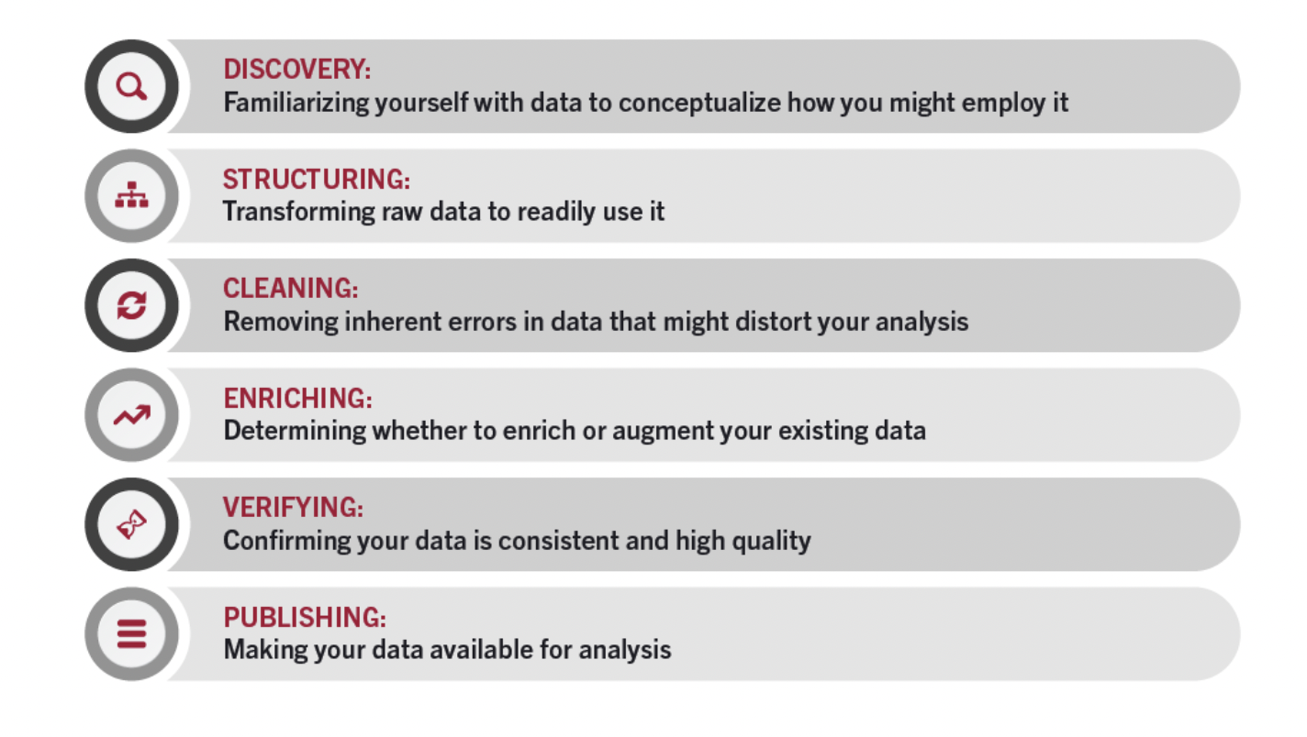

Figure 2.1: Steps in Data Wrangling

**2.3.1 DETECTING**

Exploration is the process of becoming familiar with facts so you can envision how you might use it. It's similar to looking in the refrigerator to see what we can obtain before making dinner.

During the discovery process, trends or patterns in the data might be found, as well as obvious issues like missing numbers or errors that need to be rectified.

**2.3.2 ASSEMBLING**

Basic information that is either absent or poorly organised is frequently inappropriate for the meaning intended. Information architecture is the process of gathering raw data and transforming it to make it more usable. The information may take several forms depending on the kind of analysis you use to comprehend it.

**2.3.3 SCOURING**

Cleaning up data involves removing its inherent defects, which could distort your research or render it unusable. It is possible to clean data in a variety of ways, including by removing unneeded cells or columns, finding abnormalities, and standardising inputs. The purpose of data cleaning is to ensure that there aren't any errors—or as few as are likely—that could affect the final evaluation. Finding and removing any incorrect information has a substantial impact on the remaining data wrangling activities.

**2.3.4 ENHANCING**

After comprehending the current state of knowledge and refining the information into a more useful form, we must determine whether you are in possession of all the knowledge required to execute the work at hand. Otherwise, one can choose to enhance or enrich their own collection of values by adding values received from other collections.

**2.3.5 CONFIRMING**

Data validity is a method of making sure that your information is uniform and accurate. Verification might reveal errors that need to be fixed, or it can lead to the conclusion that the data is ready for analysis. Numerous computerised operations that function as verification require coding to be completed.

**CHAPTER 3**

**LITERATURE REVIEW**

Personal curating is a common feature on websites like Spotify, Pinterest, YouTube, and Goodreads. Viewers can create collections using things like songs, images, videos, and even novels to provide a unique perspective on how something might be grouped overall. Consumer-generated product listings are frequently created, reviewed, and then managed on different websites for people. Customers frequently find potential items, determine whether to include them on a list, do so, and then possibly continue to update the list.

Automatically start and continue a mixtape. An thorough prior study with three sections has been conducted on the design and maintenance of automated song-based playlists. The first section focuses on neural networks that use learning lineups, such as a collection creating music sequencing, to assess the likelihood of an extra album.

The second method creates alternate playlists mostly using song sounds. A few examples include the one where Maillet et al. trained classifications to determine whether a group of tracks might be considered a collection of songs. The third area is most relevant to our research because it frequently forecasts the upcoming N entries using algorithms for recommendation or data mining.

Therefore, similar to song-based plays, such lists should be generated and maintained automatically . Second, most traditional album extension research assumes that playlists are always the same. The remaining cases are or, which indicate a collection of songs with speed dispersion is as comparable with the current list as the one instance of presented at the beginning.

**CHAPTER 4**

**DATASET DESCRIPTION**

Our research's main goal is to create an ordered skip prediction demonstration that can predict whether or not a client will skip over a track based on their knowledge with other songs and the melodic characteristics of the melody throughout particular listening sessions.

Table No 4.1: Dataset Description

|  |  |
| --- | --- |
| session_id | Once a person starts listening to music on spotify, at that present moment a session is created for that person, and it is referred to as session id. |
| session_length | Length of track in seconds. |
| skip_1 | if the song was only played briefly. |
| skip_2 | If just a little portion of the tune was listened to |
| skip_3 | Situation when whole track is performed. |
| not_skipped | The song that has not been skipped, and is played on Spotify Application without any pause. |
| context_switch | The song has been switched with some other song as soon as it is being played on the Spotify Application. |
| no_pause_before_play | There is no break before the following song begins to play. |
| short_pause_before_play | Prior to hearing the next song, there is a brief wait. . |
| long_pause_before_play | Before listening to the next song, there is a lengthy pause. |
| hour_of_day | It refers to the time of the day during which the song is played on the Spotify Application |
| date | The date of the year on which the song is played |
| release_year | The year on which the song is released |
| us_popularity_estimate | Success of the track. The value will range from 0 to 100, with 100 being the most typical number. It is calculated using a formula and largely depends on the date of release and the overall number of times the music has been played. In general, songs that are performed more frequently right now will be more common than songs that were frequently performed in the past. Theoretical link between musician and album success and song success. The recognition number could lag behind actual reputation by a few weeks because the number doesn't alter immediately. |
| acousticness | a scale from 0.0 to 1.0 indicating the certainty of the beat's audibility. High trust in the outermost layer's acoustical qualities is indicated by a value of 1.0. |
| beat_strength | The strength of the song's beat is determined by this; typically, the first beat is the strongest and the third beat is the weakest. |
| bounciness | Numerous musical elements, such as tempo, beat security, pulse intensity, or overall consistency, affect a song's bounciness. The number that is least delightful is 0.0, and the number that is most enjoyable is 1. |
| danceability | Numerous musical elements, such as tempo, beat security, pulse intensity, or overall consistency, affect a song's danceability. The number that is least delightful is 0.0, and the most enjoyable is 1. |
| energy | Vitality, a self-reported metric of power and action, has a range of 0.0 to 1.0. Frenetic music typically has the rapid, loud, and boisterous impression. In comparison to thrash rock, a Bach prelude does poorly on the intensity scale. Sensory factors such as range of motion, seen loudness, tone, start percentage, and general unpredictability affect the aforementioned feature. |
|  |  |
| key | Tone of audio |
| liveness | Denotes listeners and popularity of certain audio. |
| loudness | Decibels or volume of audio |
| mode | Pitch of audio |
| Acoustic_Vectors | Audibility of audio from a scale of 0 to 1. |

**CHAPTER 5**

**METHODOLOGY**

Figure 5.1: Methodology

**5.1 EDA ANALYSIS**

The strategy for data management is called EDA, and it includes elements like handling values that are missing, interpreting times, and addressing information entry irregularities. Actual data frequently contains various values that aren't present or might be presented in an unfavourable way, making it impossible to rapidly create ML models based on it. EDA is required to clean it up, prepare it for use in a model that employs ML, and to increase its accuracy and efficiency.

Several advancements took place during this stage:

1. Checking for empty values

2. merging data sets

3. Date codification

4. Get rid of the data set's numbers and category values.

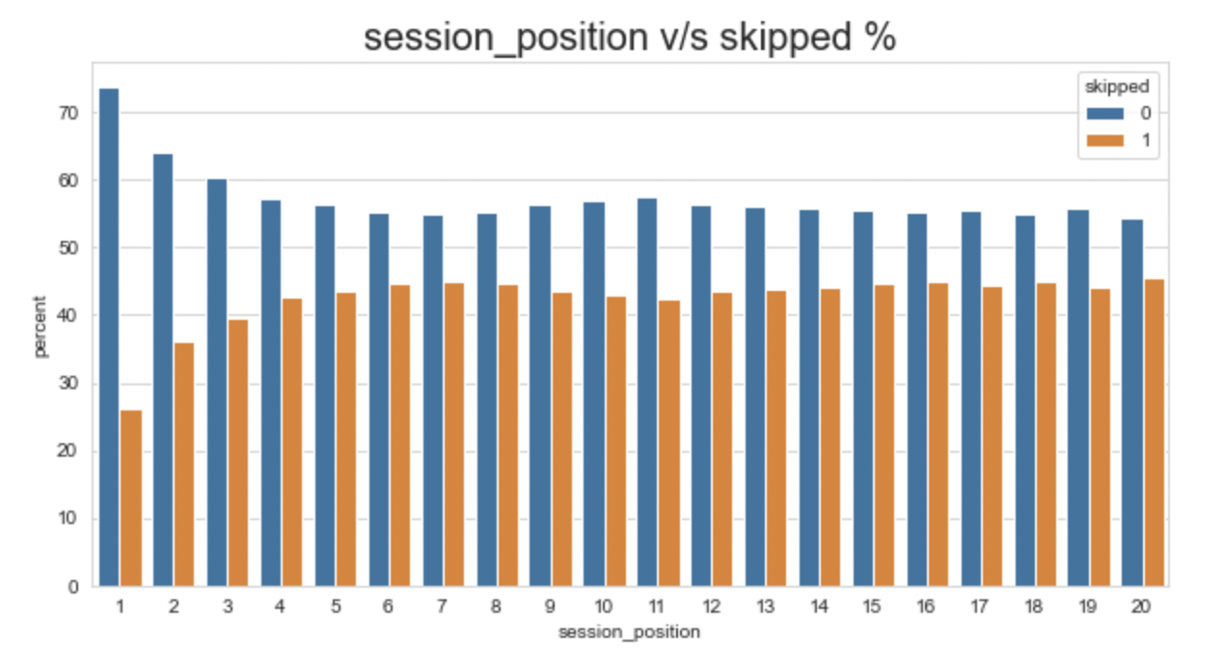

Figure 5.2: Session_position v/s skipped %

Figure 5.3: Session_length v/s skipped %

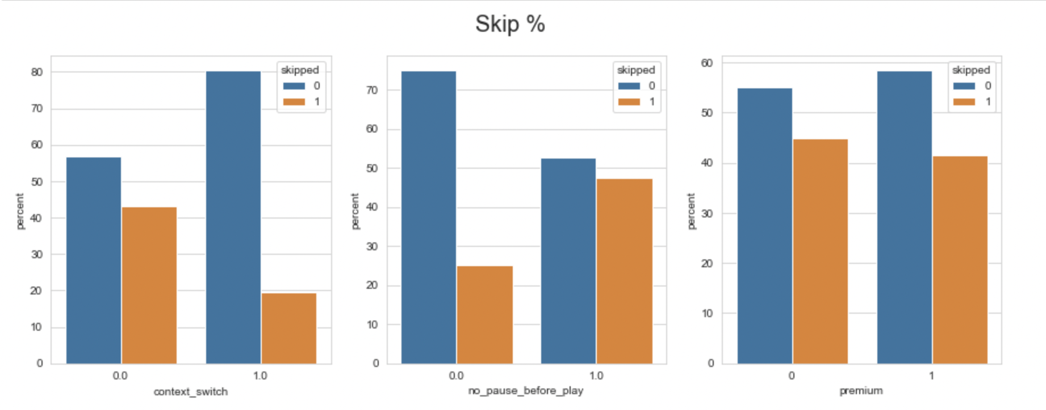

Figure 5.4: Skip%

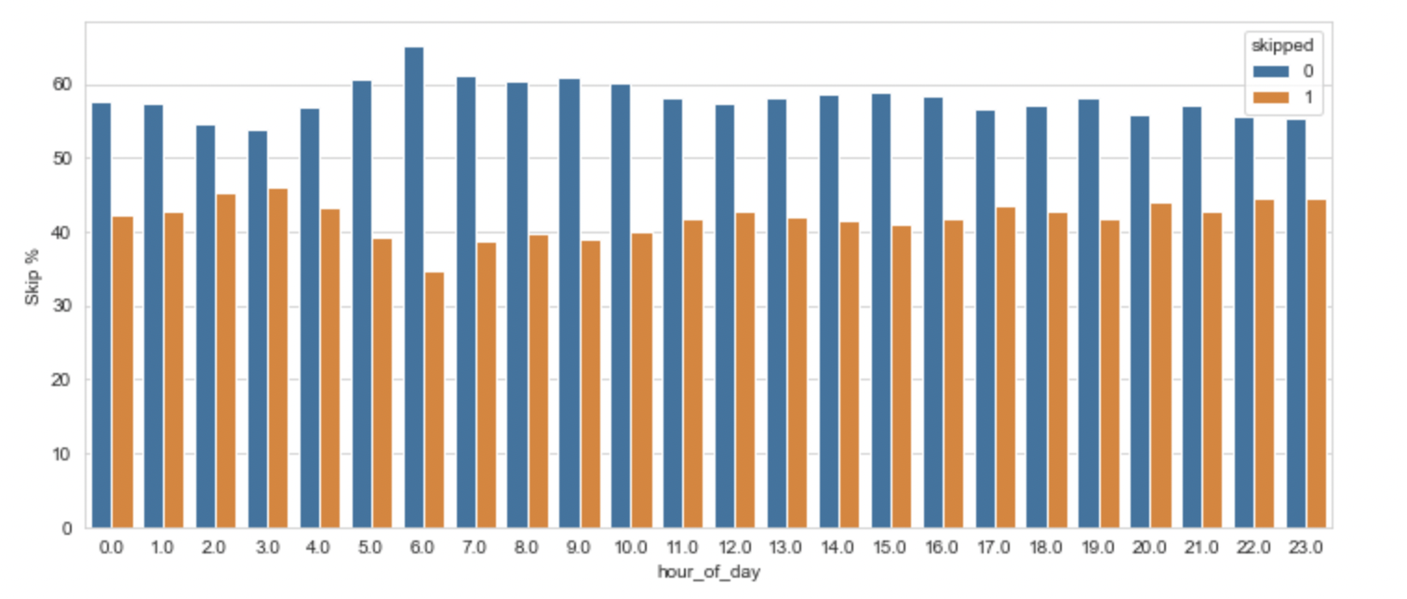

Figure 5.5: Skip% vs Hour_of_day

Figure 5.6: Skip% vs Release_year

**5.2 TRAINING MODEL**

Figure 5.7: Model Training Parameters

The building of a trained model that simplifies well-known to new familiar to unidentifiable information is the main goal of training models.

A total of 130 billion listens with 10 to twenty recordings each were made accessible for the instruction set.

About thirty million auditory meetings were included in the sample set, together with all available data for each session's opening forty minutes and forecasts for its conclusion. Only 10,000 data points were sampled for this study, with half of each recording utilised for instruction and half for testing. The information was divided into two main files, the first of which includes interaction characteristics for the tune in 22 posts, such as the time of day, the duration for the time of year, the kind of

**5.3 TEST MODEL & EVALUATION**

Figure 5.8: Confusion Matrix

**5.4 MODEL PREDICTION**

**5.4.1 RANDOM FOREST CLASSIFIER**

well-known ML approach The supervised-learning approach includes RF. It can be used for ML problems that involve both classification and regression. It is based on the concept of collaborative learning, which is a technique for combining several classifiers to handle challenging problems and improve the effectiveness of the models.

**5.4.2 XGB CLASSIFIER**

A global gradient-booster software called XGBoost has been improved for rapid and scalable neural network construction. Using this method of ensemble learning, forecasts from a number of weaker models are merged to produce a more potent estimate. Extreme-gradient enhancement, which can handle massive data sets while maintaining the forefront of many ML applications like forecasting and predicting, is one of the most widely used ML methods.

**5.4.3 DECISION TREE CLASSIFIER**

Regression and classification issues can be solved using a technique known as a DT, however it is frequently preferred for this purpose. It comprises of a classifier built on a tree structure, where the leaf nodes represent the sorted results, the interior vertices represent the properties of the dataset, and the branching represents the decision-making process.

**CHAPTER 6**

**RESULT**

**6.1 RANDOM FOREST CLASSIFIER**

Figure 6.1: Random Forest

**6.2 XGB CLASSIFIER**

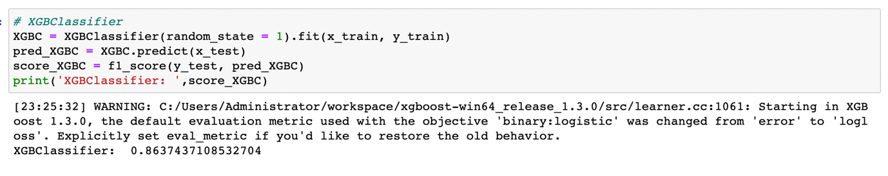Figure 6.2: XGB Classifier

**6.3 DECISION TREE CLASSIFIER**

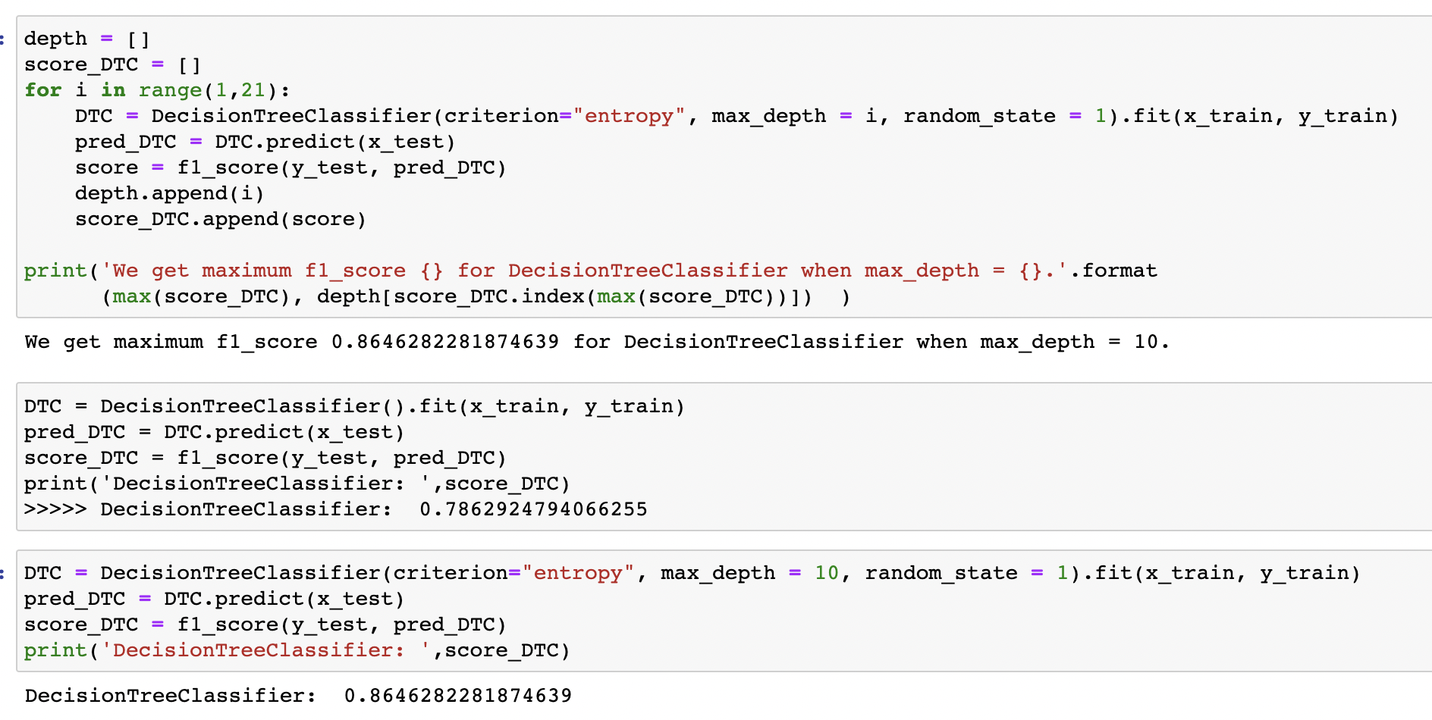Figure 6.3: Decision Tree Classifier

**6.4 K-NEAREST NEIGHBOURS**

KNN is a well-liked ML method for addressing regression and classification problems. This indirect method uses the KNN of the attribute space as the foundation for its forecasts. The KNN Classifier determines the difference between each training example and each request example. The k nearest neighbours are then identified based on the distance with the smallest difference.

As seen in 6.4, KNN Classifier accuracy is 86.46%.

Figure 6.4: KNN

**6.5 LOGISTIC REGRESSION**

Figure 6.5: Logistic Regression

**6.6 SUPPORT VECTOR MACHINE**

SVM, a powerful and flexible ML technique, is used for both classification and regression applications. SVM aims to find the optimal hyper-plane for partitioning different classes or for making predictions based on ongoing values by maximising the margin between the various courses. In order to find the hyper-plane that is farthest from the nearest points in each batch of information, the method transforms the information into a more complex field space. I calculated the Support Vector Machine's accuracy to be 85.91% in Figure 6.6.

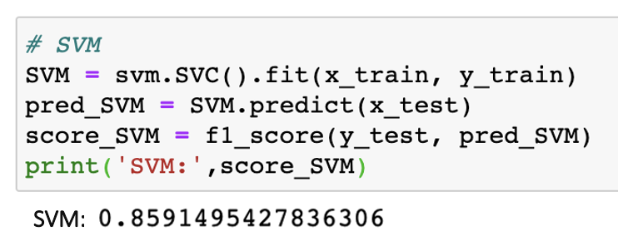

Figure 6.6: Support Vector Machine

**CHAPTER 7**

**CONCLUSION**

In a word, Spotify's track skip feature has fundamentally altered how we listen to audio by granting users greater control over how they personalise and manage their musical experiences. Participants can quickly learn about various categories, artists, or emotions by simply touching or clicking to flip between songs. This capability has enhanced the user experience by allowing users to build unique individual accounts and find new songs that suit their likes.

The introduction of track bypassing on Spotify is significantly impacting the whole music industry. Musicians are given the option to share their musical works with a wider audience because they are aware that listeners may swiftly go on to the next track even if they are not immediately engaged. Additionally, song skimming has altered the way we listen to audio and given us the freedom to adapt our musical preferences to a variety of situations and locations [70]. With Spotify's track skipping feature, it is simple to make mixes that cater to our constantly changing needs and preferences, whether one is looking for an energetic track during workout or a peaceful song after falling asleep.

**REFERENCES**

[1] Geoffray Bonnin and Dietmar Jannach. 2015. Automated generation of music playlists: Survey and experiments. ACM Computing Surveys (CSUR) (2015).

[2] Da Cao, Xiangnan He, Lianhai Miao, Yahui An, Chao Yang, and Richang Hong. 2018. Attentive group recommendation. In SIGIR.

[3] Da Cao, Liqiang Nie, Xiangnan He, Xiaochi Wei, Shunzhi Zhu, and Tat-Seng Chua. 2017. Embedding factorization models for jointly recommending items and user generated lists. In SIGIR.

[4] Ching-Wei Chen, Paul Lamere, Markus Schedl, and Hamed Zamani.

[5] https://online.hbs.edu/blog/post/data-wrangling

[6] Shuo Chen, Josh L Moore, Douglas Turnbull, and Thorsten Joachims. 2012. Playlist prediction via metric embedding.

[7] Brian McFee and Gert RG Lanckriet. 2011. The Natural Language of Playlists. In ISMIR, Vol. 11. 537–541

[8] François Maillet, Douglas Eck, Guillaume Desjardins, Paul Lamere, et al. 2009. Steerable Playlist Generation by Learning Song Similarity from Radio Station Playlists. In ISMIR. 345–350.

[9] Changtao Zhong, Sunil Shah, Karthik Sundaravadivelan, and Nishanth Sastry. 2013. Sharing the loves: Understanding the how and why of online content curation. In Seventh International AAAI Conference on Weblogs and social media.

[10] Melanie Feinberg, Gary Geisler, Eryn Whitworth, and Emily Clark. 2012. Understanding personal digital collections: an interdisciplinary exploration. In Proceedings of the Designing Interactive Systems Conference. ACM, 200–209.

[11] Caroline Lo, Justin Cheng, and Jure Leskovec. 2017. Understanding online collection growth over time: A case study of Pinterest.

[12] Yuchen Liu, Dmitry Chechik, and Junghoo Cho. 2016. Power of Human Curation in Recommendation System.

[13] Chantat Eksombatchai, Pranav Jindal, Jerry Zitao Liu, Yuchen Liu, Rahul Sharma, Charles Sugnet, Mark Ulrich, and Jure Leskovec. 2018. Pixie: A system for recommending 3+ billion items to 200+ million users in real-time.

[14] Yun He, Jianling Wang, Wei Niu, and James Caverlee. 2019. A Hierarchical SelfAttentive Model for Recommending User-Generated Item Lists. In Proceedings of the 28th ACM International Conference on Information and Knowledge Management. ACM, 1481–1490.

[15] Xiangnan He, Lizi Liao, Hanwang Zhang, Liqiang Nie, Xia Hu, and Tat-Seng Chua. 2017. Neural collaborative filtering.

[16] Balázs Hidasi, Alexandros Karatzoglou, Linas Baltrunas, and Domonkos Tikk. 2015. Session-based recommendations with recurrent neural networks. arXiv preprint arXiv:1511.06939 (2015).

[17] Jiaxi Tang and Ke Wang. 2018. Personalized top-n sequential recommendation via convolutional sequence embedding.

[18] Jingyuan Chen, Hanwang Zhang, Xiangnan He, Liqiang Nie, Wei Liu, and TatSeng Chua. 2017. Attentive collaborative filtering: Multimedia recommendation with item-and component-level attention.

[19] Xiaowen Huang, Shengsheng Qian, Quan Fang, Jitao Sang, and Changsheng Xu. 2018. CSAN: Contextual Self-Attention Network for User Sequential Recommendation.

[20] Wang-Cheng Kang and Julian McAuley. 2018. Self-Attentive Sequential Recommendation.

[21] Brian Brost, Rishabh Mehrotra, and Tristan Jehan. 2019. The Music Streaming Sessions Dataset. In Proceedings of the 2019 Web Conference. ACM.

[22] Junyoung Chung, Kyle Kastner, Laurent Dinh, Kratarth Goel, Aaron C Courville, and Yoshua Bengio. 2015. A recurrent latent variable model for sequential data. In Advances in neural information processing systems. 2980–2988.

[23] Yoav Freund and Robert E Schapire. 1997. A Decision-Theoretic Generalization of On-Line Learning and an Application to Boosting. J. Comput. Syst. Sci. 55, 1 (Aug. 1997), 119–139.

[24] Sepp Hochreiter and Jürgen Schmidhuber. 1997. Long short-term memory. Neural computation 9, 8 (1997), 1735–1780. [5] Tomas Mikolov, Kai Chen, Greg Corrado, and Jeffrey Dean. 2013. Efficient estimation of word representations in vector space. arXiv preprint arXiv:1301.3781 (2013).

[26] Kay I Penny. 1996. Appropriate critical values when testing for a single multivariate outlier by using the Mahalanobis distance. Journal of the Royal Statistical Society: Series C (Applied Statistics) 45, 1 (1996), 73–81.

[27] Pascal Vincent, Hugo Larochelle, Yoshua Bengio, and Pierre-Antoine Manzagol. 2008. Extracting and composing robust features with denoising autoencoders. In Proceedings of the 25th international conference on Machine learning. ACM, 1096–1103.

Cantador I, Cremonesi P (2014) Tutorial on cross-domain recom-

mender systems. In: Proceedings of the 8th ACM conference on

recommender systems, RecSys’14. ACM, New York, NY, USA,

pp 401–402. https://doi.org/10.1145/2645710.2645777

29. Cantador I, Fernández-Tobías I, Berkovsky S, Cremonesi P (2015)

Cross-domain recommender systems. Springer, Boston, pp 919–

959. https://doi.org/10.1007/978-1-4899-7637-6_27

30. Carenini G, Smith J, Poole D (2003) Towards more conversational

and collaborative recommender systems. In: Proceedings of the

8th international conference on intelligent user interfaces, IUI’03.

ACM, New York, NY, USA, pp. 12–18. https:// doi.org/10.1145/

604045.604052

31. Cebrián T, Planagumà M, Villegas P, Amatriain X (2010) Music

recommendations with temporal context awareness. In: Pro-

ceedings of the 4th ACM conference on recommender systems

(RecSys), Barcelona, Spain

Cantador I, Cremonesi P (2014) Tutorial on cross-domain recom-

mender systems. In: Proceedings of the 8th ACM conference on

recommender systems, RecSys’14. ACM, New York, NY, USA,

pp 401–402. https://doi.org/10.1145/2645710.2645777

29. Cantador I, Fernández-Tobías I, Berkovsky S, Cremonesi P (2015)

Cross-domain recommender systems. Springer, Boston, pp 919–

959. https://doi.org/10.1007/978-1-4899-7637-6_27

30. Carenini G, Smith J, Poole D (2003) Towards more conversational

and collaborative recommender systems. In: Proceedings of the

8th international conference on intelligent user interfaces, IUI’03.

ACM, New York, NY, USA, pp. 12–18. https:// doi.org/10.1145/

604045.604052

31. Cebrián T, Planagumà M, Villegas P, Amatriain X (2010) Music

recommendations with temporal context awareness. In: Pro-

ceedings of the 4th ACM conference on recommender systems

(RecSys), Barcelona, Spain

Cantador I, Cremonesi P (2014) Tutorial on cross-domain recom-

mender systems. In: Proceedings of the 8th ACM conference on

recommender systems, RecSys’14. ACM, New York, NY, USA,

pp 401–402. https://doi.org/10.1145/2645710.2645777

29. Cantador I, Fernández-Tobías I, Berkovsky S, Cremonesi P (2015)

Cross-domain recommender systems. Springer, Boston, pp 919–

959. https://doi.org/10.1007/978-1-4899-7637-6_27

30. Carenini G, Smith J, Poole D (2003) Towards more conversational

and collaborative recommender systems. In: Proceedings of the

8th international conference on intelligent user interfaces, IUI’03.

ACM, New York, NY, USA, pp. 12–18. https:// doi.org/10.1145/

604045.604052

31. Cebrián T, Planagumà M, Villegas P, Amatriain X (2010) Music

recommendations with temporal context awareness. In: Pro-

ceedings of the 4th ACM conference on recommender systems

(RecSys), Barcelona, Spain

Cantador I, Cremonesi P (2014) Tutorial on cross-domain recom-

mender systems. In: Proceedings of the 8th ACM conference on

recommender systems, RecSys’14. ACM, New York, NY, USA,

pp 401–402. https://doi.org/10.1145/2645710.2645777

29. Cantador I, Fernández-Tobías I, Berkovsky S, Cremonesi P (2015)

Cross-domain recommender systems. Springer, Boston, pp 919–

959. https://doi.org/10.1007/978-1-4899-7637-6_27

30. Carenini G, Smith J, Poole D (2003) Towards more conversational

and collaborative recommender systems. In: Proceedings of the

8th international conference on intelligent user interfaces, IUI’03.

ACM, New York, NY, USA, pp. 12–18. https:// doi.org/10.1145/

604045.604052

31. Cebrián T, Planagumà M, Villegas P, Amatriain X (2010) Music

recommendations with temporal context awareness. In: Pro-

ceedings of the 4th ACM conference on recommender systems

(RecSys), Barcelona, Spain

[28] Stuart Cunningham, Stephen Caulder, and Vic Grout. 2008. Saturday Night or Fever? Context-Aware Music Playlists. In Proceedings of the 3rd International Audio Mostly Conference: Sound in Motion. Pitea, Sweden. ˚

[29] Sally Jo Cunningham, David Bainbridge, and Anne Falconer. 2006. ‘More of an Art than a Science’: Supporting the Creation of Playlists and Mixes. In Proceedings of the 7th International Conference on Music Information Retrieval (ISMIR). Victoria, BC, Canada.

[30] Sally Jo Cunningham, David Bainbridge, and Dana Mckay. 2007. Finding New Music: A Diary Study of Everyday Encounters with Novel Songs. In Proceedings of the 8th International Conference on Music Information Retrieval. Vienna, Austria, 83–88.

[31] Sally Jo Cunningham, J. Stephen Downie, and David Bainbridge. 2005. “e Pain, e Pain”: Modelling Music Information Behavior And e Songs We Hate. In Proceedings of the 6th International Conference on Music Information Retrieval (ISMIR 2005). London, UK, 474–477.

[32] L. Dey, M. U. Asad, N. Afroz, and R. P. D. Nath. 2014. Emotion extraction from real time chat messenger. In 2014 International Conference on Informatics, Electronics Vision (ICIEV). 1–5. DOI:hp://dx.doi.org/10.1109/ICIEV.2014.6850785

[33] Justin Donaldson. 2007. A Hybrid Social-acoustic Recommendation System for Popular Music. In Proceedings of the ACM Conference on Recommender Systems (RecSys). Minneapolis, MN, USA, 4.

[34] Gideon Dror, Noam Koenigstein, Yehuda Koren, and Markus Weimer. 2011. e yahoo! music dataset and kdd-cup’11. In Proceedings of the 2011 International Conference on KDD Cup 2011-Volume 18. JMLR. org, 3–18.

[35] Greg Dunn, Jurgen Wiersema, Jaap Ham, and Lora Aroyo. 2009. Evaluating Interface Variants on Personality Acquisition for Recommender Systems. In Proceedings of the 17th International Conference on User Modeling, Adaptation, and Personalization: formerly UM and AH (UMAP ’09). Springer-Verlag, Berlin, Heidelberg, 259–270.

[36] Shrey Dua and Hema A. Murthy. 2014. Discovering Typical Motifs of a Raga from One-Liners of Songs in Carnatic Music. In Proceedings of the 15th International Society for Music Information Retrieval Conference (ISMIR). Taipei, Taiwan, 397–402.

[37] Georgi Dzhambazov, Ajay Srinivasamurthy, Sertan S¸enturk, and Xavier Serra. ¨ 2016. On the Use of Note Onsets for Improved Lyrics-to-audio Alignment in Turkish Makam Music. In 17th International Society for Music Information Retrieval Conference (ISMIR 2016). New York, USA.

[38] Samira Ebrahimi Kahou, Vincent Michalski, Kishore Konda, Roland Memisevic, and Christopher Pal. 2015. Recurrent Neural Networks for Emotion Recognition in Video. In Proceedings of the 2015 ACM on International Conference on Multimodal Interaction (ICMI ’15). ACM, New York, NY, USA, 467–474.

[39] Hamid Eghbal-zadeh, Bernhard Lehner, Markus Schedl, and Gerhard Widmer. 2015. I-Vectors for Timbre-Based Music Similarity and Music Artist Classification. In Proceedings of the 16th International Society for Music Information Retrieval Conference (ISMIR). Malaga, Spain.

[40] Mehdi Elahi. 2011. Adaptive active learning in recommender systems. User Modeling, Adaption and Personalization (2011), 414–417.

[41] Mehdi Elahi, Mahias Braunhofer, Francesco Ricci, and Marko Tkalcic. 2013. Personality-based active learning for collaborative filtering recommender systems. In AI* IA 2013: Advances in Artificial Intelligence. Springer International Publishing, 360–371.

[42] Mehdi Elahi, Francesco Ricci, and Neil Rubens. 2014. Active Learning Strategies for Rating Elicitation in Collaborative Filtering: A System-wide Perspective. ACM Transactions on Intelligent Systems and Technology 5, 1, Article 13 (Jan. 2014), 33 pages.

[43] Mehdi Elahi, Francesco Ricci, and Neil Rubens. 2016. A survey of active learning in collaborative filtering recommender systems. Computer Science Review 20 (2016), 29–50.

[44] Asmaa Elbadrawy and George Karypis. 2015. User-specific feature-based similarity models for top-n recommendation of new items. ACM Transactions on Intelligent Systems and Technology (TIST) 6, 3 (2015), 33.

[45] Mehmet Erdal, Markus Kachele, and Friedhelm Schwenker. 2016. ¨ Emotion Recognition in Speech with Deep Learning Architectures. Springer International Publishing, Cham, 298–311. DOI:hp://dx.doi.org/10.1007/978-3-319-46182-3 25